

**AI Smart للعقارات**

**Software Development Plan For Smart للعقارات**

***Faculty of Computer and Information***

***Luxor University***

**TITLE PAGE CONTENT**

**DATE**

Version Beta.

**Project Advisors:**

Dr. Mohamed Ramadan.

Eng. Mohamed Ahmed Mohamed.

**Submitted by:**

1) Mohamed AbdElrahman Elkhlawy

2) Waleed AbdElmeged Alassar

3) Mohamed Roshdy Tawfik Soliman

4) Samar Sayed AbdElaal

5) Mohamed Gabrallah Sayed

6) Yasser Ayman

**REVISION HISTORY**

| **Date** | **Author** | **Distributed to** | **Version** | **Description** |
| --- | --- | --- | --- | --- |
| DD\ MM\YYYY | name | who | Matches title page | Brief description of change |

**TABLE OF CONTENTS**

**1. PRODUCT DESCRIPTION**

### Product Description

Our project is a site for selling and renting apartments and displaying all the details of the apartment in terms of location, price, and interior details of the apartment, in addition to pictures, videos, and any other details that the user may need.

### Client Description

Our client is a real estate rental company that operates in the property sector. The company aims to provide high quality and reliable rental services for apartments and properties to its clients. The company is committed to offering a unique rental experience to its clients, where quality and high-level service are the primary focus.

Services:

The company provides a variety of rental services related to properties, including:

1- Residential and commercial apartment rentals of different sizes and specifications.

2- Consulting services related to property rentals, including guidance and advice for clients on suitable properties, pricing, and other matters related to property rentals.

Objective:

The company aims to provide a high quality and reliable rental experience for its clients, with the goal of achieving customer satisfaction and ensuring their return in the future. The company also aims to increase brand awareness, expand its customer base, and achieve sustainable profits and growth in the market.

### Audience and Goals

#### **Audience:**

**The target audience for the real estate rental company includes individuals and families looking to rent apartments or properties. The company may also target business professionals, international students, and expats who require temporary housing.**

#### **Product Goals:**

1. **To provide a wide range of rental properties that cater to the diverse needs and budgets of its customers.**

**2. To establish the company as a trusted and reliable brand in the real estate rental market, with a strong reputation for customer satisfaction.**

**3. To grow the company's customer base and market share through effective marketing strategies and word-of-mouth referrals.**

**4. To maximize profits while maintaining competitive pricing to ensure that the company's rental properties remain accessible to a broad range of customers.**

**2. TEAM DESCRIPTION**

|  |  |  |  |  |
| --- | --- | --- | --- | --- |
| Member Name | First Skill | Second Skill | Third Skill | Fourth Skill |
| محمد عبد الرحمن احمد الخلاوى | Documenter | Presentator | UML Designer | Fluent in English both Oral and Written |
| وليد عبد المجيد الاعصر | Full Stack Developer | Experience in AI and Machine Learning |  |  |
| محمد رشدى توفيق سليمان | Front End | Documenter | UML Designer | Technical Support |
| سمر سيد عبد العال | Full Stack Developer. | Low Experience in AI | UML Designer |  |
| محمد جبرالله سيد | Back End | Low Experience in Front End | UML Designer |  |
| ياسر ايمن | Documenter | Speaker | Bug Hunter |  |

**3. SOFTWARE PROCESS MODEL DESCRIPTION**

Our Software Process Model will be Agile for coming reasons:

1) To break the project into several phases (sprints)

2) We will involve a constant collaboration with our stakeholders and customers.

3) We will be at a continuous improvement at every stage.

4) We will make daily meetings with the teamwork.

5) Our project have the availability to be modifiable at any time with any new requirements.

6) Our project provide simplicity in everything

## 4. PRODUCT DEFINITION

**Context Diagram**

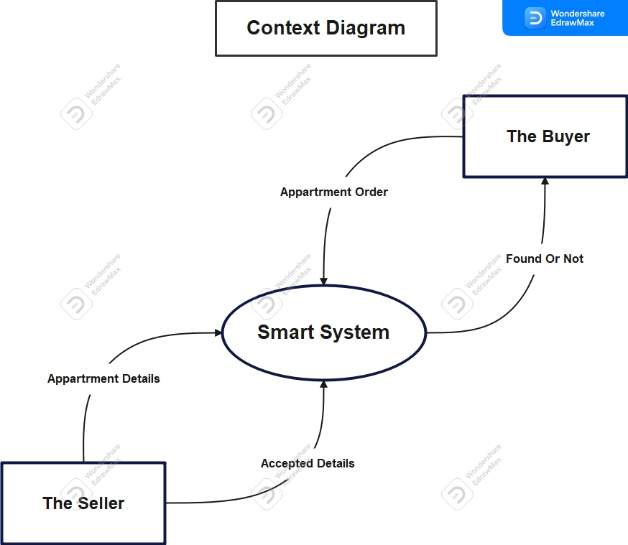

**Personas**

1) The Buyer: This user deals with the system and searches for apartments with different details.

2) The Seller: This user deals with the system and uploads the details of the real estate in addition to some pictures and videos of the property.

3) System Admin: He is an advanced type of user, as he is characterize by additional powers such as modifying real estate details, solving problems facing the system, and solving problems of other users.

**User Stories**

1) As a renter, I want to be able to search for apartments by location, price, number of bedrooms/bathrooms, look at the photos and videos of apartment and amenities so that I can find the right apartment for my needs.

2) The ability to communicate with the landlord to visit the apartment, evaluate it and agree it, and agree on the details of the real estate.

3) As a renter, I want to be able to rate and review the apartment and landlord/property manager through the app so that other renters can benefit from my experience.

4) As a seller, I want to be able to create a listing for my apartment, including photos, descriptions, and pricing, so that potential buyers can view my property online.

5) As a seller, I want to be able to communicate with potential buyers to answer any questions they may have about the property.

**High Level Use Cases**

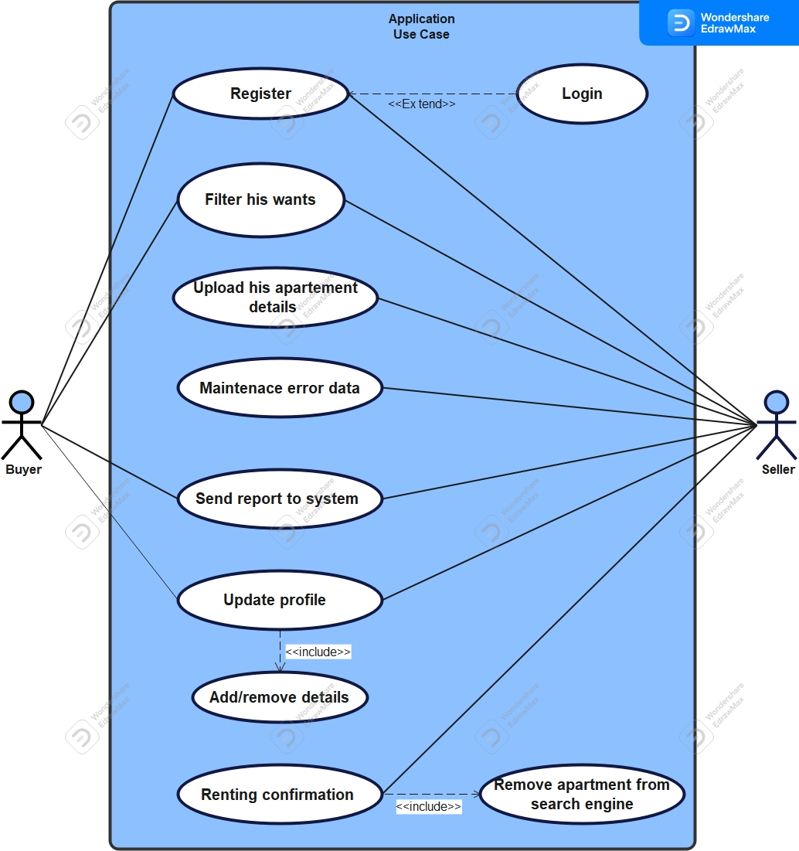

**Figure 1. Application Use case.**

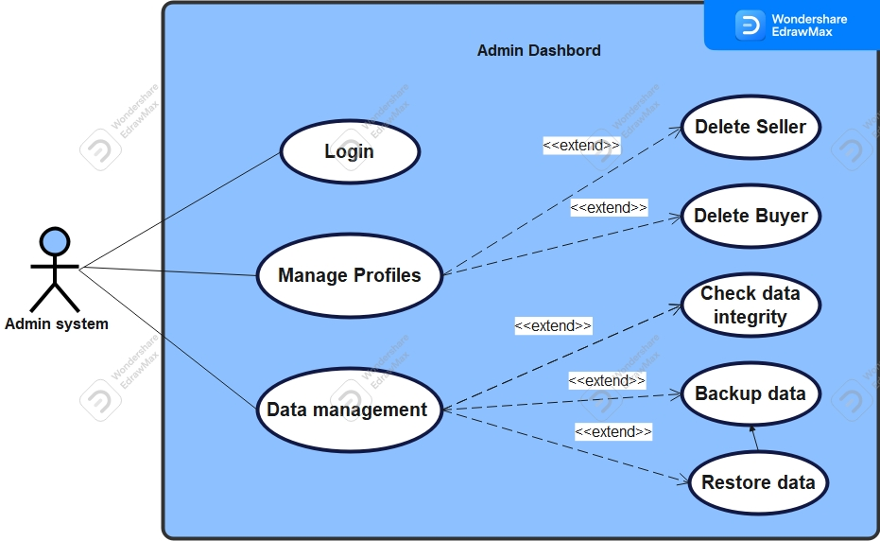

**Figure 2. Admin Dashboard Use case.**

### Use Case Descriptions:

|  |  |
| --- | --- |
| ***Use case name*** | Register, Login. |
| ***Area*** | Application. |
| ***Actor(s)*** | Buyer, Seller, System Admin. |
| ***Entry Conditions*** | User isn’t logged in or signed up to our website. |
| ***Exit Conditions*** | User already logged in to his or her account, or signed up and make an account for the first time. |
| ***Flow of Events*** | 1) The user opens our website  2) If he already has an account he login with his account.  3) If not logged in before he will sign up for the first time.  4) If he will sign up, he will enter his username and password and rewrite password for confirmation and some data about this user.  5) After sign up, he will make login with his account and password.  6) If the account and password is correct he will enter the website with his account, else he will get an error message to make a login again. |
| ***Special Requirements*** | 1) He did not sign up before, so he will go to sign up process.  2) He made a sign up before, so he will go to log in process. |

|  |  |
| --- | --- |
| ***Use case name*** | *Filter his wants.* |
| ***Area*** | Application. |
| ***Actor(s)*** | Buyer, Seller. |
| ***Entry Conditions*** | Each user needs to login to his account. |
| ***Exit Conditions*** | Each user after searching about his wanted details he will terminate the search process. |
| ***Flow of Events*** | 1) The user goes to the search page after finishing the log in process.  2) User start to use the filters in the website that match with the details that he wants to know.  3) After he finishes the search process and reach to his wanted details, he will terminate the search page. |
| ***Special Requirements*** | 1) For Buyer he will search for an apartment with his preferred details to find the appropriate one for him.  2) For Seller he will search to know more details about the prices and details for the apartments in this region before upload his apartment details. |

|  |  |
| --- | --- |
| ***Use case name*** | Upload his apartment details. |
| ***Area*** | Application. |
| ***Actor(s)*** | Seller. |
| ***Entry Conditions*** | Seller needs to log in to his account. |
| ***Exit Conditions*** | After the seller upload his apartment details and get the process accept message, he terminates this process |
| ***Flow of Events*** | 1) The seller go after finishing the searching process, he goes to the uploading page  2) He starts to put his apartment details like location, price, number of bedrooms/bathrooms, and any interior details for the apartments  3) He also upload some photos and videos for the apartment  4) Finally, he will add ways to communicate with him, like his number or social media pages and so on |
| ***Special Requirements*** | **-**The seller has an apartment and want to rent or sell it, so he uploads its’ details on our website to be viewed with any one wants an apartment and his details match with its’ detail. |

|  |  |
| --- | --- |
| ***Use case name*** | Maintains error data. |
| ***Area*** | Application. |
| ***Actor(s)*** | Seller, System Admin. |
| ***Entry Conditions*** | Seller and System Admin needs to log in to their accounts. |
| ***Exit Conditions*** | After the seller or system admin finishes the maintence process, they will terminate the process |
| ***Flow of Events*** | 1) If there were any failure in details and the admin catch it, he will hide this apartment from the search engine  2) The admin communicates with the seller of this apartment and tell him about the failure details  3) The seller then goes to correct the failure in the information of his apartment  4) Then admin check the information again if it became right, admin will make it available in the search engine again  5) If the seller did not correct it until a specific time, the admin will delete this apartment from the website forever |
| ***Special Requirements*** | - If there is any failure information about any apartment, the maintence process should done by the system admin and the seller of this apartment, to give other users a reliable information about the apartments. |

|  |  |
| --- | --- |
| ***Use case name*** | Send report to system. |
| ***Area*** | Application. |
| ***Actor(s)*** | Buyer, Seller. |
| ***Entry Conditions*** | Buyer and Seller needs to log in to their accounts. |
| ***Exit Conditions*** | After the buyer or the seller make his report and sends him to the system, this process ends |
| ***Flow of Events*** | 1) If the buyer or the seller found any problem or something happen with him on the system or with another user  2) This user starts to make a report  3) In this report he explains the problem that happens with him in details and ask for help in this problem  4) Finally, he submits this report and sends it to the system |
| ***Special Requirements*** | **-**If any user faces any problem with our system, he immediately starts to make a report about this problem to be solved in a short time  . |

|  |  |
| --- | --- |
| ***Use case name*** | Update user profile. |
| ***Area*** | Application. |
| ***Actor(s)*** | Buyer, Seller. |
| ***Entry Conditions*** | Buyer and Seller needs to log in to their accounts. |
| ***Exit Conditions*** | After the buyer or the seller make his report and sends him to the system, this process ends. |
| ***Flow of Events*** | 1) The user opens the website  2) Then he goes to his profile  3) Then he starts to edit his information on his profile to make it up to date  4) Finally, he submits the changes to be update with his profile |
| ***Special Requirements*** | **-**If any user has any changes on his profile information, then he should edit his profile to be up to date with his new information  . |

|  |  |
| --- | --- |
| ***Use case name*** | Renting confirmation for buyer. |
| ***Area*** | Application. |
| ***Actor(s)*** | Buyer, Seller. |
| ***Entry Conditions*** | Buyer and Seller needs to log in to their accounts. |
| ***Exit Conditions*** | After the seller confirm the renting or buying process on the website, it is process terminated. |
| ***Flow of Events*** | 1) The seller opens the website first.  2) Then goes to the confirmation process for this apartment.  3) Finally, he confirms that this apartment had been sold to remove it from the search engine. |
| ***Special Requirements*** | **-** If the seller has found a buyer and they reached to an agreement about this apartment, then he must go to the website to confirm that this apartment has been no longer available to be rent or sell.  . |

|  |  |
| --- | --- |
| ***Use case name*** | Manage Profiles. |
| ***Area*** | Admin Dashboard. |
| ***Actor(s)*** | System Admin. |
| ***Entry Conditions*** | System Admin needs to log in to his account. |
| ***Exit Conditions*** | After system admin complete the management of system data successfully, this process terminates. |
| ***Flow of Events*** | 1) Usually, system admin checks the data integrity of the system.  2) If there are any problems with system data.  3) System Admin check the backup data immediately.  4) If backup data is safe, he starts to restore the missed data from the backup.  5) If he catches any warnings or illegal actions on the data, he immediately closes any access to the system data, until make sure from the safety of the data actions. |
| ***Special Requirements*** | **-**The data should be checked daily to make sure from its’ safety, and if there were any illegal actions on the system data, immediately close the access to this data. |

|  |  |
| --- | --- |
| ***Use case name*** | Data Management. |
| ***Area*** | Admin Dashboard. |
| ***Actor(s)*** | System Admin. |
| ***Entry Conditions*** | System Admin needs to log in to his accounts, and there is a user even a seller or buyer whose account make illegal action on the system. |
| ***Exit Conditions*** | After system admin delete the account that do illegal actions, this process terminated. |
| ***Flow of Events*** | 1) First, the admin will get a report or catch an account doing illegal actions on the system or anything that is unavailable on our system  2) Admin will track the actions of this account to make sure from the reports he got  3) If the admin makes sure that this account doing illegal actions, he will remove it immediately from the system |
| ***Special Requirements*** | **-**If the admin knows that there is an account doing illegal actions on the system, immediately he takes the action and remove it from the system.  . |

**5. USER EXPERIENCE WIREFRAMES**

Initial prototype screens to validate initial understanding of the product.

**6. PROJECT ORGANIZATION**

Breakdown of major tasks and schedule

**Matrix of Responsibilities**

Defines the high level which team members are responsible for which tasks

**PERT / Gantt Chart**

First cut at schedule

**7. VALIDATION PLAN**

**Test Strategy**

What is the definition of done?

What does success look like?

**8. FEASIBILITY STUDY**

What are the known risks and how will they be handled?

**Risk Identification**

Description of the risks

**Risk Prioritization**

Prioritized list (biggest risk -> lowest risk)

**Risk Mitigation**

How will risk factors be addressed? By when?

What are you going to prototype?

**9. CONFIGURATION AND VERSION CONTROL**

Specify the process and attributes for version control for all project and product artifacts

**10. TOOLS**

Provide a list of tools required for the project and their use

**11. ARCHITECTURE**

List of hardware or other subsystems required for the product.